**https://laravel.com/docs/12.x/reverb**

**php artisan install:broadcasting**

It will promp this and just click yes:

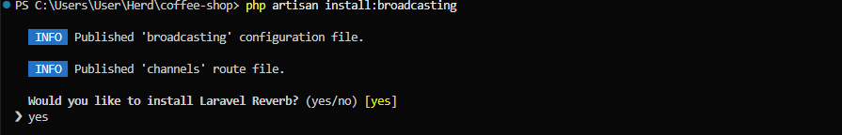

**Create an event:**

**php artisan make:event ToastEvent**

<?php

namespace App\Events;

use Illuminate\Broadcasting\Channel;

use Illuminate\Broadcasting\InteractsWithSockets;

use Illuminate\Broadcasting\PresenceChannel;

use Illuminate\Broadcasting\PrivateChannel;

use Illuminate\Contracts\Broadcasting\ShouldBroadcast;

use Illuminate\Foundation\Events\Dispatchable;

use Illuminate\Queue\SerializesModels;

class ToastEvent implements ShouldBroadcast

{

    use Dispatchable, InteractsWithSockets, SerializesModels;

    public $message;

    public function __construct($message)

    {

         $this->message = $message;

    }

    public function broadcastOn(): array

    {

        return [

            new PrivateChannel('toast-channel-'.data_get($this->message,'user_id',null)),

        ];

    }

    public function broadcastAs()

    {

        return 'toast.broadcast.'.$this->message['user_id'];

    }

}

**In routes**

Broadcast::channel('toast-channel-{id}', function ($user, $id) {

    return true; // or custom logic

});

**Make a file echo.ts**

import Echo from 'laravel-echo';

import Pusher from 'pusher-js';

window.Pusher = Pusher;

declare global {

    interface Window {

        Pusher: any;

        Echo:any

    }

}

export const echo = new Echo(

    {

    broadcaster: 'reverb',

    key: import.meta.env.VITE_REVERB_APP_KEY,

    wsHost: import.meta.env.VITE_REVERB_HOST,

    wsPort: import.meta.env.VITE_REVERB_PORT ?? 80,

    wssPort: import.meta.env.VITE_REVERB_PORT ?? 443,

    forceTLS: (import.meta.env.VITE_REVERB_SCHEME ?? 'https') === 'https',

    enabledTransports: ['ws', 'wss'],

}

);

**Usage**

import { echo } from '@/lib/echo';

    useEffect(() => {

        echo.private('toast-channel-' + user.id)

            .listen('.toast.broadcast.' + user.id, (e: any) => {

                    console.log(e.message.value);

            });

    }, [])

**Run**

**php artisan reverb:start or php artisan reverb:start --debug**

**php artisan queue:work**